Control Engineering II

Handout – Online Laboratory 3

Name: *Colda Andreea Ariana*

Group: *30332*

**Task 1:** Process identification. The output signal to be controlled is the level in the main tank. The input signal is the inflow coming from the variable flow pump P3. The PLC is the controller (you implement the control algorithm on this controller). The transfer function of the process is obtained as:

Add transfer function and validation on the experimental data (plot the step response and the real-life data on the same graph)

1

Hf = -------

1.053 s

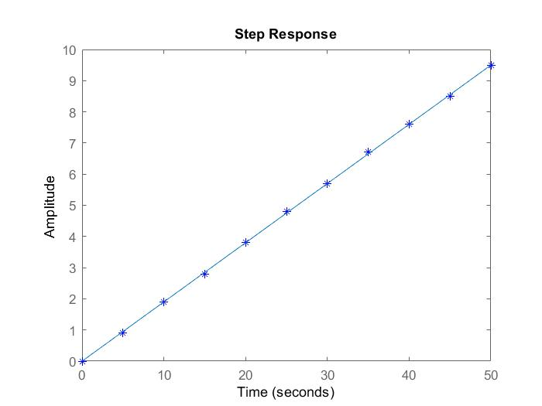

**Task 2:** For the previously determined transfer function Hf(s), design a P controller that ensures a settling time of ts=200 seconds. Simulate the closed loop response to a step reference signal of 10cm and check that the design specification is met. Verify also the control signal.

Add obtained controller and plots here

Hc_P = 0.02105

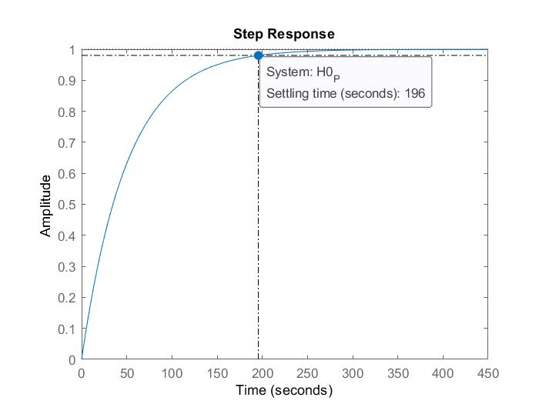

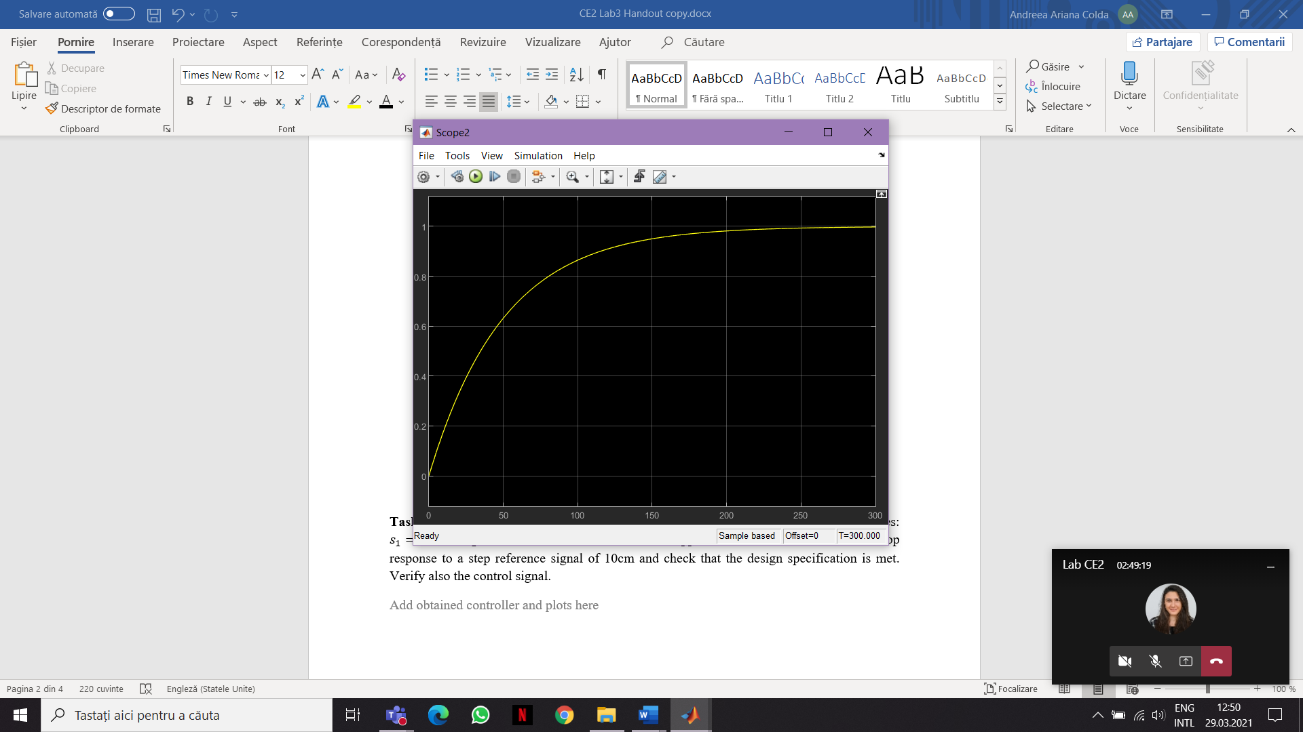

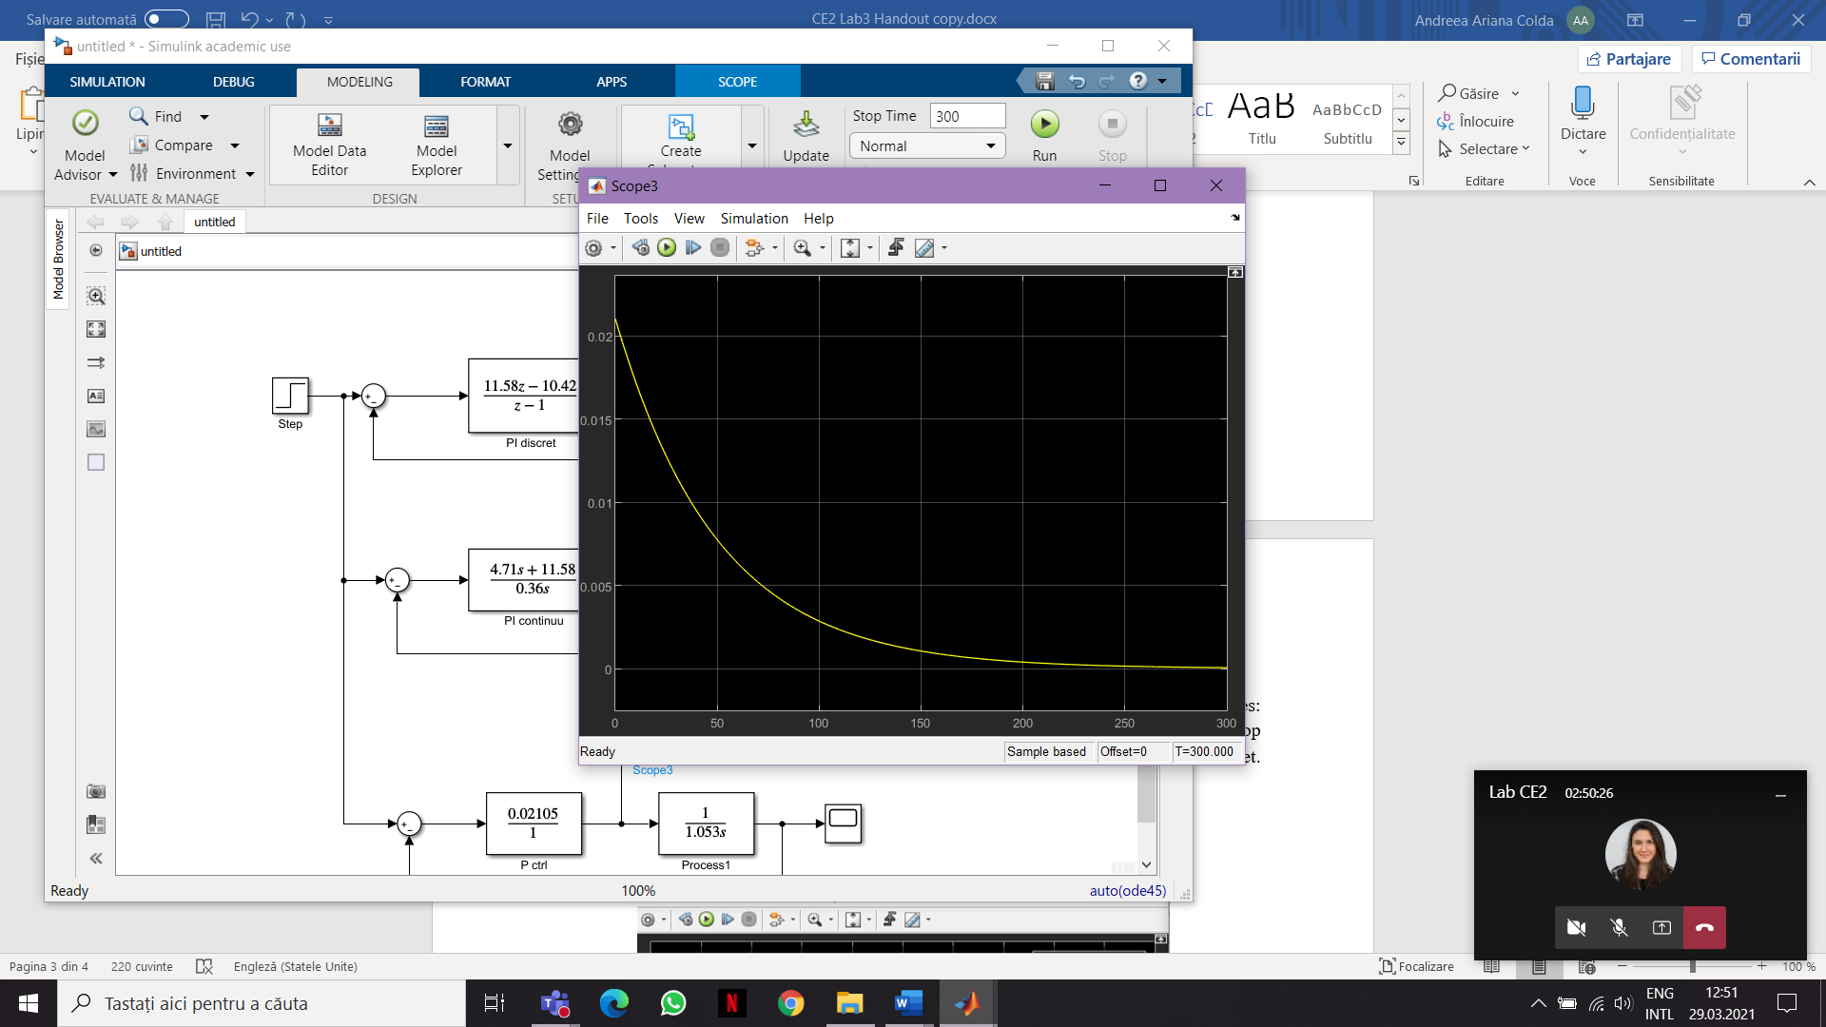

**Task 3:** Design a PI controller such that the closed loop transfer function will have two poles: $s_{1}=-5$ and $s_{2}=-6$. Determine its discrete-time approximation. Simulate the closed loop response to a step reference signal of 10cm and check that the design specification is met. Verify also the control signal.

Add obtained controller and plots here

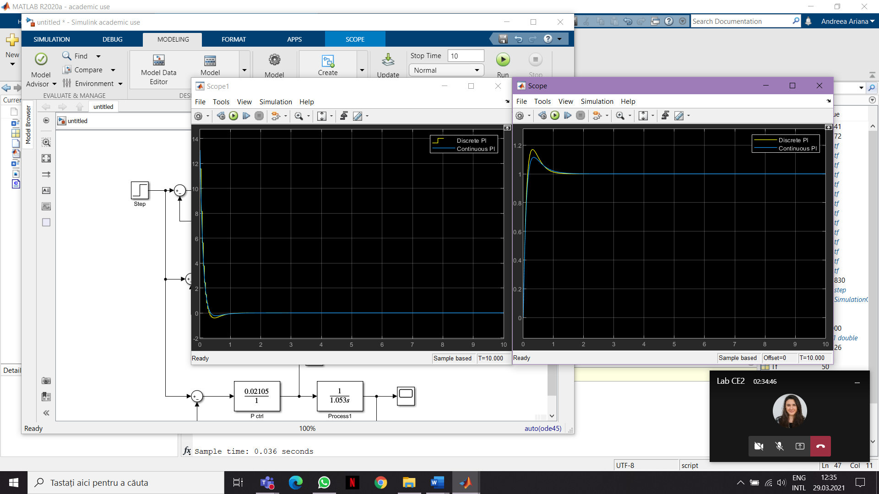

11.58 z - 10.42 4.17 s + 11.58

Hc_PI_d = --------------- Hc_PI = --------------

z – 1 0.36 s

